**Military Institute of Science and Technology**

Department of Computer Science and Engineering

Course Title: Data and Tele-Communication Sessional

Course Code: CSE-318, Cr. Hr: 1.50

Level-3, Term-2

###### Experiment No. 11

###### Name of the Experiment: Design and Implementation of Delta Modulation and Demodulation.

**Objectives:**

**The main objectives of this experiment are**

1. To study signal digitization using Delta Modulator and reconstruction using Delta Demodulator.
2. To observe the effect of Slope overload problem and its remedy.

**Equipment needed:**

1. MODICOM 4 Board
2. IC Power 60 unit
3. Set of connection leads
4. Multi meter
5. Oscilloscope

**Theory**:

**The three voice digitization techniques are:**

* Pulse Code Modulation (PCM)
* Adaptive Pulse Code Modulation (ADPCM)
* Delta Modulation (DM)

The operation of the delta modulator is as follows: The input signal is applied to a comparator, whose output will be high if the non inverting input is greater than the inverting input, and low in the opposite case. The output of this comparator is applied to a bi stable type D, which at the same time, will provide us an output in each clock cycle that will be the data output.

This data output is also applied to the input of the level changer, whose mission is to convert the high level into a continuous voltage of -4 volts, and the low level into +4 volts. These outputs are inserted into the input of an inverter integrator that generates an increasing slope if its input is of -4 volts, and a decreasing one in the other case. The output of the integrator is applied to the inverting input of the comparator, closing the loop of the circuit.

To better understand the operation of the modulator, consider the figure given below.





Suppose the time instant t=0. In that moment the analogical signal input is more positive than the output of the integrator, this originates a high level at the output of the comparator, which at the same time generates a high level at the output of the bistable, which will be synchronized with clock signal. In other words, the modulator is transmitting a bit 1.

The high level, at the same time, is the input of the level changer, which will give a continuous signal of -4 V at its output, which will be converted into an increasing slope at the output of the inverter integrator, which will be the inverting input of the comparator at the time t=1.

In t=1, the signal originates from the inverter is more positive than the analogical input signal. This will give rise to a low level at the output of the comparator. This output will also be present at the output of the bistable. In this case the following bit transmitted will be 0.

This low level, on being applied to the level changer, cause an opposite effect to that previously described, giving rise this time to a decreasing slope that will be applied to the comparator. The process continues for the rest of the time instant as can be seen in figure given in the previous page.

In this figure we can also visualize the effect that the overload error would produce. The signal generated by the integrator has a constant increasing and decreasing slope, this implies that if the analogical signal varied very quickly, the modulator would not be able to follow it, giving rise to an overload error.

The delta demodulator receives data flow, each of which will pass in each clock cycle through the bistable D. From the output of the bistable, each bit will enter a circuit level changer identical to that of the modulator, that is to say, it will generate a continuous value of -4 V if the bit that arrives is a 1, and a value of +4 V if the bit that arrives is a 0.

The output of the level changer is applied to an inverter integrator, also identical to that of the modulator, which will produce a signal equal to that of the modulator but with different amplitude and a certain delay. The output of the integrator is then filtered through a low-pass filter that will give us the original signal as output.

**Procedure:**

1. Adjust the transmitter and receiver level changer.

**Transmitter Level Changer Setup Procedure:**

* Connect the transmitter clock output tp2 to the clock input of the D-type Bi stable tp174.
* Connect the voltage comparator output tp8 to the data input on the D-type Bi stable tp16.
* On the voltage comparator connect the inverting input tp6 to 0v and the non-inverting input tp7 to the Bipolar output of the level changer tp19.
* Use your oscilloscope to monitor the level changer output at tp19.
* Carefully turn the level adjust preset until the monitored waveform is symmetrical about the 0v level.

**Receiver Level Changer Setup Procedure:**

* Connect the receiver clock output tp3 to the clock input of the D-type Bi stable tp32.
* Connect the voltage comparator output tp8 to the data input on the D-type Bi stable tp31.
* Connect the voltage comparator output tp8 to the level changer bipolar output tp34.
* Use your oscilloscope to monitor the level changer output at tp34.
* Carefully adjust the level adjust preset until the monitored waveform is symmetrical about the 0-v level.

1. Carry out the assembly specified in figure given in next page.
2. Set the switches A and B of the clock generation block in the position 00, which is equivalent to the frequency of 32 KHz.
3. Set the gain switch of the integrator blocks in the left position. In the same manner, set the switches A and B of both integrators in the position.

A=0, B=0.

1. Set the potentiometer of the signals of 250 Hz, 500Hz, 1KHz and 2KHz so that their output will be maximum.
2. Set the console switch, or that of the power supply being used, in the position ON.
3. **ADJUSTMENT OF THE MODULATOR**

It should be adjusted using a continuous level of 0V, therefore, adjust the DC potentiometer until it gives a level of 0V.

Connect this signal of 0 V to the positive input of the comparator.

Using an oscilloscope, visualize the existing signal in the output of the transmitter integrator. This must be a triangular signal centered on 0V. In the event of not having a stable trace in the oscilloscope, move the potentiometer located in the level changer of the transmitter. The amplitude of this triangular signal must be of about 0.5 volts peak to peak. Once this has been done, the transmitter is ready.

**Adjustment of the Demodulator**

Visualize the signal at the output of the receiver integrator. This signal must be the same as that of the transmitter and ideally centered on 0V. If this is not so, try to adjust it using the potentiometer of the level changer of the receiver and of the integrator itself. This last is located in the upper part of the board. Once this has been done, the demodulator is adjusted.

1. Once the adjustment has been done, disconnect the continuous signal from the positive points of the comparator and in their place we will connect the sinusoidal signal of 250 Hz.
2. Visualize the signal at the output of the transmitter integrator. Note how the integrator follows the analogical signal. For a stable trace in the oscilloscope, it may be necessary to readjust the potentiometer of the level changer of the transmitter.
3. Visualize the signal at P19 and observe that, in fact a data flow is being transmitted.
4. Visualize together the signal at the output of both integrators. Note that these signals are very similar and that of the receiver present a slight delay.
5. See the signal at the output of the receive filter. Note that the recovered signal mat be slightly fuzzy. This fuzziness is due to a quantification error produced by the size of the integrator step. Increasing the frequency of the clock can reduce the error.
6. Change the frequency of the clock using the switches A and B of the clock generation block as indicated on the board itself and observe the previous signals. See how the fuzziness has reduced and the transmission has improved.
7. Reset the switches A and B of the clock generation block in the position A=0 and B=0.
8. Remove the signal of 250 Hz from the positive input of the comparator and in its place, put the signal of 2 KHZ.
9. Visualize the signal at the output of the integrator. You will observe that we have triangular signals. This means that the integrator is not following the analogical signal; therefore an overload error has been produced.
10. Increase the clock frequency of the system and observe that the error still exists. Leave the system in the clock frequency of 256 KHZ and the switches A and B in the positions A=1, B=1.
11. In a delta modulator-demodulator system there are three possible ways to solve the overload error:
    * Reduction of the input signal frequency
    * Reduction of the input signal amplitude
    * Increase in the integrator gain
12. The first case has already been studied. With the signal of 250 Hz there were no overload problems, while with that of 2 KHz this error always appeared. Now, study the other two possibilities.
13. Reduce the amplitude of the signal of 2 KHz while visualizing the output of the transmitter integrator. Observe how, when the amplitude is reduced, the integrator is already capable of following the input signal.
14. The other way is to increase the integrator gain. For this, set the switches A and B of both integrator blocks in the position A=1 and B=1. Note how the overload error has disappeared. The gain of the integrator operates in the following way: there are four positions according to the position of A and B(B being the less significant bit). Each time we pass from one position to the next gain is doubled.
15. Test the assembly with the two remaining signals and draw conclusions.

**Report**:

1. Draw and submit all the wave shapes, you observe at different test points, with your report. Discuss the nature of the wave shapes. (Wave shapes should be drawn on graph papers)
2. What are the advantages of DM over PCM, DPCM and ADPCM?
3. Brief discuss slope overload noise and granular noise occurred in DM.
4. “DM is basically a 1 bit DPCM”-explain this statement.
5. How can the S/N (signal to quantization noise ratio) performance of DM system be improved?

**Reference:**

1. MODICOM 4 manual
2. “Modern Digital and Analog Communication Systems” ------by B. P. Lathi
3. “Communication System”----- by Haykin
4. “Modern Communication Systems – Principles and Applications” -----by Leon W. Couch II

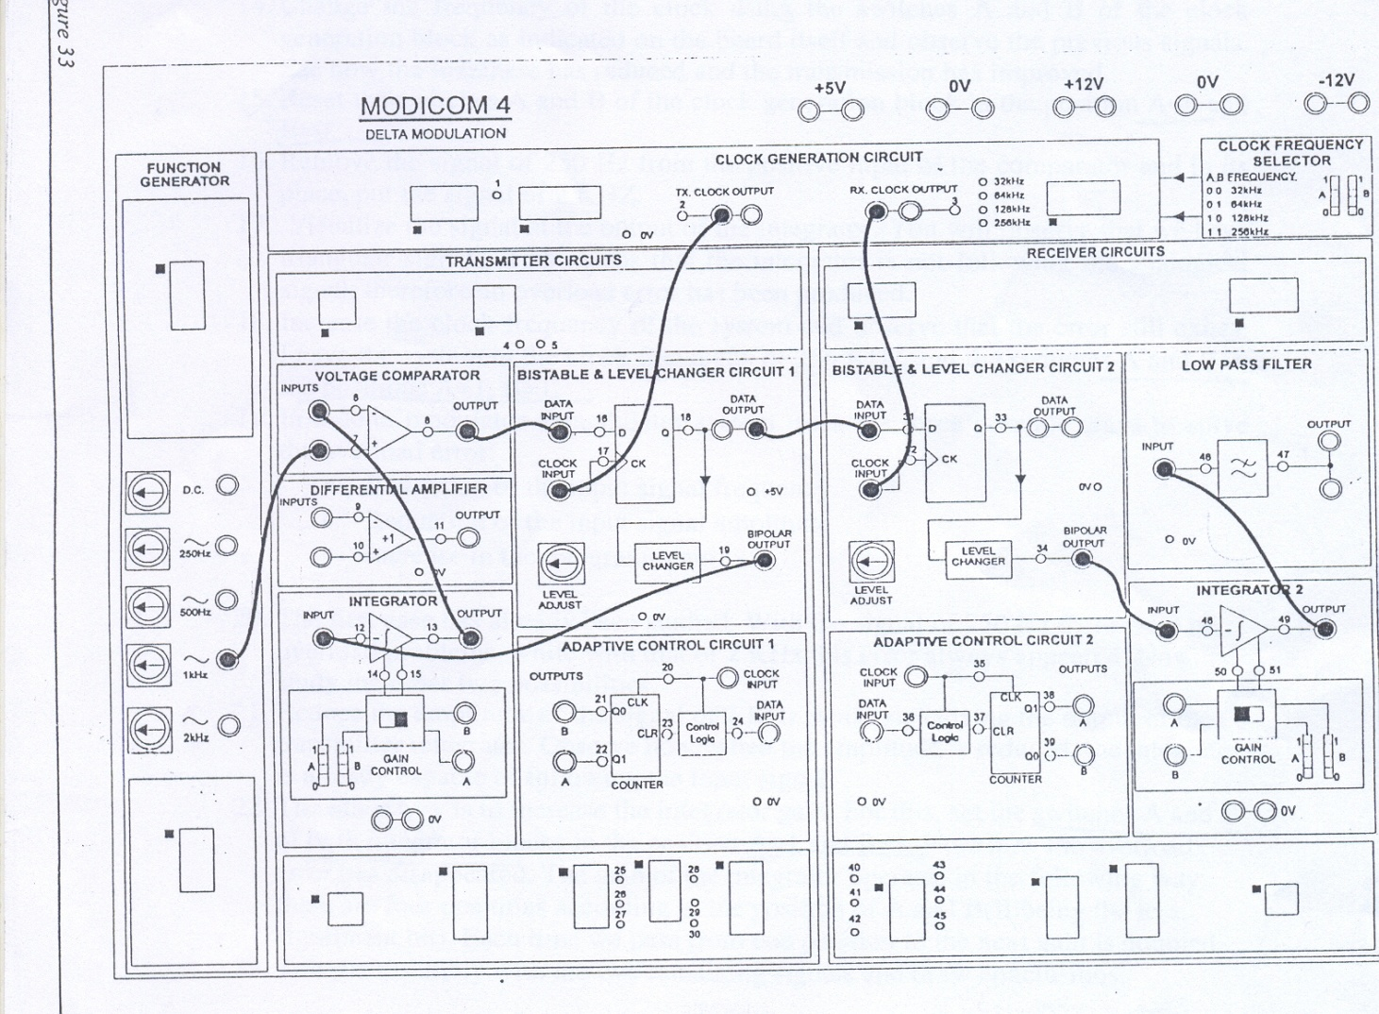

# Figure: Detail Connection of Delta Modulation and Demodulation